

RECONTEXTUALIZING THE WORDS “DISTANCE” AND “DISTANCING” DURING THE COVID-19 PANDEMIC

Moh. Kavin Lidinillah
Moh. Shofi Zuhri

Tarbiyatut Tholabah Islamic Institute
shofizuhri@iai-tabah.ac.id

Abstract
COVID-19 is a plague that has become a pandemic for the world. Necessary, many researchers who conduct research to understand about COVID-19, both medical and other scientific disciplines such as language science. The purpose of this study is to find out whether there is a contextualization of the words DISTANCE and DISTANCING with SOCIAL kolokat. For this reason, the mixed method is used to obtain coherent results. The results of this study indicate that the T-score of DISTANCING 16.1 and DISTANCE -14. This shows that the word SOCIAL is more commonly used with the word DISTANCING in corpora. The second finding is a re-contextualization of the word DISTANCING in the negative direction.
Keywords: Corpus-Based Analysis, Critical Strategies, COVID-19, Recontextualization

INTRODUCTION
This study aims to show the differences in function and/or meaning of a text or word in a context that cannot be seen clearly when using only one linguistic discipline. To that end, this study uses corpus linguistics and critical discourse studies to show the subtle differences between collocation and text meaning. Corpus linguistics is described as a linguistic study based on the ‘real language’ of everyday life (McEnery & Wilson, 2001). Of course, this understanding is not enough to understand the purpose of corpus linguistics. Corpus linguistics is a large collection of data in the form of texts (or parts of texts) that are stored online and can be accessed for the purpose of knowing language rules if needed in a language study. With the various types of corpora that exist today, it is easier for language researchers to uncover various linguistic significances that previously could not be seen from one perspective of linguistic theory. Therefore, corpus linguistics can be considered as a methodology that has a wide range of applications in language studies because it can be used in various areas and existing language theories (McEnery, Xiao, & Tono, 2006). This can be achieved because corpus linguistics can focus on examining a specific keyword or collocation. Keywords themselves are lexical components that indicate that a word appears more often than other words in a text (Stubbs, 2001). These keywords can be extracted using various software such as Sketch Engine which has the ability to search for these keywords within a context.
The meaning of a word cannot be separated from the situation (context) of the use of the word. The use of a word in a certain context can produce a discourse that is different from the literal meaning of the word. Often the meaning of a word or phrase can change depending on how and in what circumstances the expression is said. This cannot be separated from the existence of social and cultural relationships to the meaning of a word or phrase. So, our understanding of language is not only about understanding the meaning of each word, but also understanding the form of word combinations and cultural understanding of the word (Stubbs, 2001). The change of meaning of a word in a context certainly cannot be separated from collocation. Collocation is a repeated relationship between at least two lexical items in one direct syntactic arrangement (Bartsch, 2004). Of course, to understand the meaning contained in a collocation, it does not only require an understanding of the words that make up the collocation and the culture in which the collocation is used, but also requires a scientific perspective such as semantics. In addition, time also plays an important role in understanding the meaning contained because a word or collocation can change meaning depending on the time and context at that time. Therefore, recontextualizing the meaning of a collocation is the main topic in this study.
Recontextualization is a process of extracting words, signs or meanings from their original context and reusing them in a different context. Because of their use in a different context, there is a change in the definition and meaning of the word (Connolly, 2015). Previously, there has been a study on the recontextualization of a word conducted by Salama (2011) which focused on ideology in collocation and recontextualization in the word Wahabi after the 9/11 incident. The study attempted to find out the changes in ideology and meaning of the words WAHHABI, WAHHAB'S, and SAUDI. The results of this study indicate that collocation can be a micro part of the formation of an ideology in text or non-text which can result in the recontextualization of ideology in social practice.
This study aims to determine the recontextualization of the word DISTANCE in the COVID-19 corpus. This is done to determine whether there is a change in the meaning of the word DISTANCE in certain collocations. With the use of the word DISTANCE in certain contexts and having different collocations during this pandemic, the researcher aims to determine the recontextualization of the word along with its collocations.

RESEARCH METHOD
This study is a synergy study between corpus linguistics and word recontextualization. Corpus linguistics is used as a tool to obtain and collect data samples that will be used as analysis data. Furthermore, the data that has been obtained will be analyzed using the recontextualization method by Linell (1998). To obtain relevant research results, this study uses a mixed method involving quantitative and qualitative methods. Creswell (2017) explains that mixed methods are an approach used to provide a more comprehensive understanding.
This study uses Sketch Engine as the main tool for processing the corpus and uses the COVID-19 corpus as the main corpus in this study. Sketch Engine is a corpus processing tool that has the ability to analyze text along with collocations to find out the use of keywords in a context. Meanwhile, the COVID-19 corpus is an open access corpus that is part of the COVID-19 Open Research Dataset (CORD-19). This corpus contains medical texts from various scientific articles that aim to help researchers research the novel coronavirus. Sketch Engine is used to find the frequency of the words DISTANCE and DISTANCING along with the collocations of the words. The data taken is data that appeared in the time period from July to December 2019 and January to May 2020. After obtaining data samples from that time period, the data will be analyzed using the recontextualization method proposed by Linell (1998).
To obtain comprehensive data results, the data samples that have been obtained will be calculated for observed frequency and expected frequency before the data is compared. Afterwards, the data that has been obtained will be studied using the recontextualization theory. Based on the previous explanation, there are several stages carried out in this study, which are as follows:
a. Collecting DISTANCE and DISTANCING data,
b. Calculating the T-score of DISTANCE and DISTANCING, followed by comparing the α value (p-value),
c. Associating the results obtained with the recontextualization theory.

FINDINGS
The keywords in this study are the words DISTANCE and DISTANCING using collocations -5 and +5. In the 2019 data, the number of observed frequencies was 489 from DISTANCE and 15 from DISTANCING. In this data, there were 0 co-occurrences for the word SOCIAL with DISTANCE and 14 co-occurrences for the word DISTANCING. Furthermore, the 2020 data showed an observed frequency of 1588 from DISTANCE and 1267 from DISTANCING. There were 98 co-occurrences for the words SOCIAL and DISTANCE. While for DISTANCING, there were 1112 co-occurrences for the word SOCIAL.
Table1. Observed Frequency 2019
 | Distance (2019) | Distancing (2019) | Total
Social | 0 | 14 | 14
Non-Social | 489 | 1 | 490
Total | 489 | 15 | 504

Table2. Observed Frequency 2020
 | Distance (2020) | Distancing (2020) | Total
Social | 98 | 1112 | 1210
Non-Social | 1490 | 155 | 1645
Total | 1588 | 1267 | 2855

Furthermore, to strengthen the data from observed frequency, the expected frequency is needed in this study (Brezina, 2018). So the expected frequency can be obtained through the following formula:

Table3. Expected Frequency 2019
Expected  Frequency |  | Dependent Variable |  |  | Total
 |  | Value 1 | Value2 |  | R1
Independent  Variable | Value 1 | 13.5 | 0.4 |  | R1
Independent  Variable | Value 2 | 475.4 | 14.5 |  | R2
Total

Table4. Expected Frequency 2020
Expected  Frequency |  | Dependent Variable |  |  | Total
 |  | Value 1 | Value2 |  | R1
Independent  Variable | Value 1 | 673 | 536.9 |  | R1
Independent  Variable | Value 2 | 914.9 | 730 |  | R2
Total

After getting the observed frequency and expected frequency, then to find out the keywords that are most often associated with the word SOCIAL, the T-score value is needed to find out. The T-score can be found using the following formula:

t = 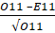

Table5. T-score & MI
 | Distance (2019) | Distancing (2019) | Distance (2020) | Distancing (2020)
T-score | - | 3.5 | -14.4 | 16.1
MI | - | -9.3 | -15.6 | -7.8

Based on the table above, it can be concluded that the word SOCIAL is a colloquial word that is more often found with the keyword DISTANCING than with the keyword DISTANCE. In the 2019 data, the word SOCIAL was not found in collocation with the word DISTANCE. This makes the T-score and MI of the word SOCIAL with DISTANCE null due to the absence of data. On the other hand, the T-score of SOCIAL with DISTANCING is 3.5. In the 2020 data, the T-score and MI of DISTANCING are higher than DISTANCE with values ​​of 16.1 and -14.4 and -7.8 and -15.6 respectively. Based on these data, it can be concluded that both in 2019 and 2020 the word SOCIAL is more often associated with the word DISTANCING than the word DISTANCE. The difference in frequency between the two is quite high when looking at the T-score and MI values.
Representation of DISTANCE
As shown in table 6 below, the word DISTANCE has no co-occurrence with the word SOCIAL in 2019. The word DISTANCE has more co-occurrence with words other than SOCIAL such as pairwise, long, genetic, phylogentic, and travel. These words have a context that can be said to be neutral for the word DISTANCE.
Table6. Collocates of DISTANCE in 2019
 | Collocate | Cooccurrences | T-score | MI
DISTANCE (total freq. 489) | pairwise | 22 | 4.69 | 16.5
DISTANCE (total freq. 489) | long | 41 | 6.4 | 14.98
 | genetic | 51 | 7.14 | 14.55
 | phylogenetic | 27 | 5.2 | 14.81
 | travel | 21 | 4.58 | 14.88

Concordance in Figure 1 shows that the word DISTANCE more often has collocations with neutral words and does not carry a particular ideology. These words when carried with the word DISTANCE do not show any significant contextual changes in their use in sentences. Collocations for the word DISTANCE are more neutral than positive or negative.

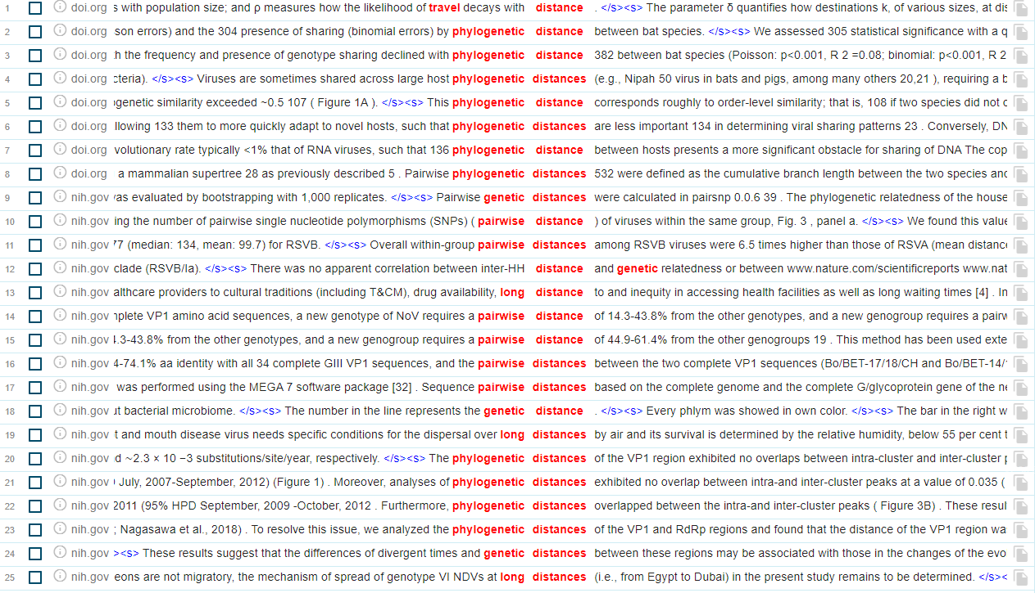
Figure1. Concordance of DISTANCE in 2019

Based on the example in Figure 1, the word DISTANCE is often used as a collocation for other words as a word that indicates the distance will be appropriate. As in the context in line 1, where the word DISTANCE is collocation with the word TRAVEL. The word DISTANCE shows that distance will affect something to decay when on a journey. The sentence does not have a positive or negative meaning. The collocation that occurs provides a neutral context to the reader because there is no negative condition or effect from the words that are juxtaposed. Meanwhile, the collocation found paired with the word DISTANCE in the 2020 data shows that the collocation related to the word DISTANCE has a neutral context. The collocation that occurs with the word DISTANCE shows that the word is often used in a neutral sentence context. So it does not give a negative or positive impression to the reader. This can be seen from the table showing the collocation for the word DISTANCE below:
Table7. Collocates of DISTANCE in 2020
 | Collocate | Cooccurrences | T-score | MI
DISTANCE (total freq. 1588) | interpersonal | 64 | 8 | 16.87
DISTANCE (total freq. 1588) | pairwise | 39 | 6.24 | 14.94
 | social | 93 | 9.64 | 12.28
 | attitude | 24 | 4.9 | 14
 | weighted | 22 | 4.69 | 14.46

To find out the use of collocations in table 7, it is necessary to know the concordance of the colloquialism with the word DISTANCE. Based on figure 2, it can be concluded that the colloquialism that is paired with the word DISTANCE has a neutral sentence contextually. The colloquialism does not show any change in contextual meaning in its use with the word DISTANCE.
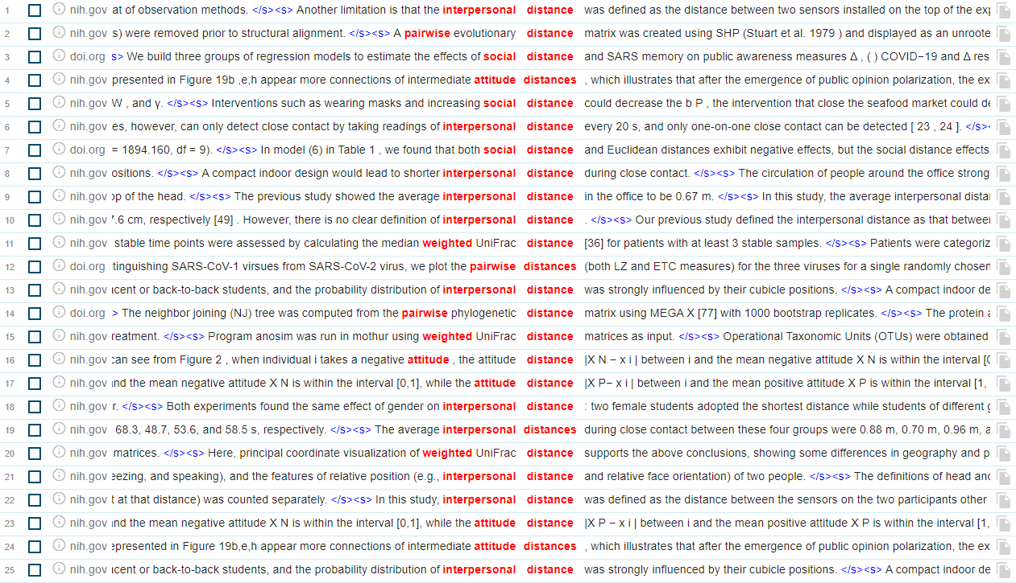
Figure2. Concordance of DISTANCE in 2020
In Figure 2, it can be seen that the use of colloquialisms found with the word DISTANCE shows that the word does not change the contextual meaning of the word DISTANCE itself. This also shows that the word DISTANCE when carried with the colloquialisms in table 7 has a neutral connotation. However, there are some uses in contexts that have positive meanings such as in line 12. In this context, "pairwise distance" has a positive context because the concordance shows that there is a pairwise distance to determine a virus.
Representation DISTANCING
To find out the contextual function of the keyword DISTANCING, it is necessary to have colloquial phrases that appear together with the keyword. Based on table 8 below, it can be concluded that the word DISTANCING more often meets or appears together with the colloquial phrase SOCIAL compared to other colloquial phrases.
Table8. Collocates of DISTANCING in 2019
 | Collocate | Cooccurrences | T-score | MI
DISTANCING (total freq. 19) | closing | 4 | 2 | 21.84
DISTANCING (total freq. 19) | social | 14 | 3.74 | 18.71
 | measures | 9 | 3 | 17.26
 | evaluate | 3 | 1.75 | 16.23

Based on the table above, it can be concluded that in the 2019 data with 19 occurrences, the word DISTANCING appears together with the word SOCIAL. This shows that the word DISTANCING is most often associated with the word SOCIAL compared to other colloquial words. To find out the meaning and contextual use of the collocations DISTANCING and SOCIAL, the contextual use can be seen in Figure 3 below:
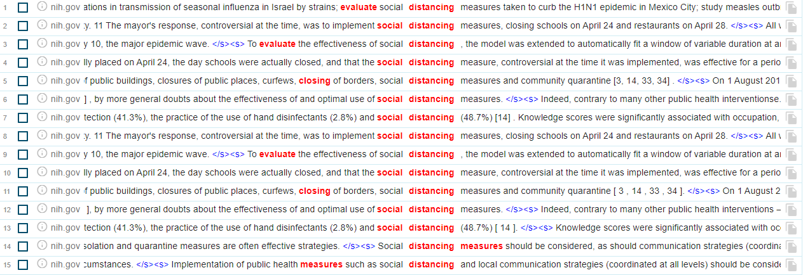
Figure3. Concordance of DISTANCE in 2019
The word DISTANCING has the most associations with the word SOCIAL. This shows that the keyword often appears together with the word SOCIAL. The context of the collocation of these two words is a positive context because it has the meaning of a recommendation to maintain social distancing for the common good. The purpose of the SOCIAL DISTANCING collocation is to urge the public to maintain distance within social community groups, both in carrying out activities outside the home and other activities that involve gathering people in large numbers to break the chain of transmission of the COVID-19 pandemic.
Data in 2020 for the keyword DISTANCING itself shows that there has been a significant increase in the use of the word DISTANCING with the word SOCIAL. The data can be seen in table 9 below:
Table9. Collocates of DISTANCING in 2020
 | Collocate | Cooccurrences | T-score | MI
DISTANCING (total freq. 1267) | social | 1112 | 33.35 | 16.06
DISTANCING (total freq. 1267) | measures | 294 | 17.15 | 13.84
 | interventions | 109 | 10.44 | 13.95
 | physical | 48 | 6.93 | 13.65

Based on the table above, the word DISTANCING has a high association with the word social. Based on the data, the word DISTANCING meets the word SOCIAL 1112 times out of 1267 occurrences in the COVID-19 corpus. This shows that the word DISTANCING is often paired with the word SOCIAL in its use in a sentence context.

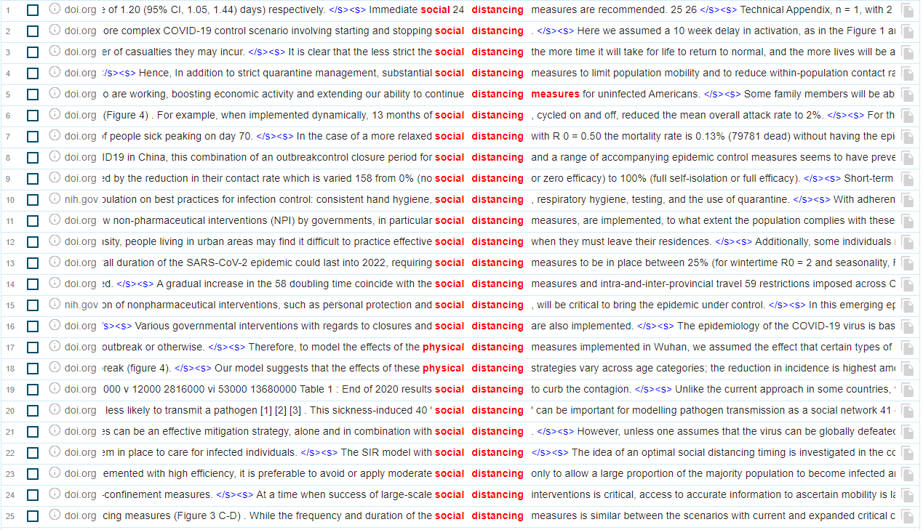
Figure4. Concordance of DISTANCE in 2020
In its use in sentences, the collocation of the words SOCIAL and DISTANCING creates a negative context in 2020. This is because the context of this sentence has a change in meaning because it shows a recommendation to apply an attitude of self-awareness of oneself and the environment which if not obeyed will cause the spread of the COVID-19 pandemic. Thus, the collocation of the word SOCIAL DISTANCING in 2020 has a negative context.

DISCUSSION
There are 2 important points in this study; 1) the word DISTANCE, both in 2019 and 2020 data, has fewer co-occurrences with the word SOCIAL compared to DISTANCING. This shows that the word SOCIAL has less contextual significance to the word DISTANCE but has contextual significance to the word DISTANCING. 2) There is a recontextualization of the word DISTANCING when juxtaposed with the word SOCIAL.
Linell (1998), explains that there are three different levels of recontextualization. The first level is intratextual recontextualization; recontextualization that occurs in the same text, discourse or conversation. The second level is intertextual recontextualization; recontextualization that occurs between elements of words, signs or meanings. The last recontextualization is interdiscursive recontextualization; recontextualization that occurs in various types of discourse, more abstract and less specific. The recontextualization that occurred in the study was the third type of recontextualization because the recontextualization occurred between discourses and was less specific but still had changes.

CONSLUSION
From the findings above, there are two main findings in this study. The first finding is that the word DISTANCE is rarely associated with the word SOCIAL. The collocation that occurs between the two only occurs in 2020 and does not occur in 2019. Meanwhile, for the word DISTANCING, the word is highly associated with the colloquial SOCIAL and also has a high co-occurrence. The second finding is that the collocation between the words SOCIAL and DISTANCING produces a recontextualization of the word DISTANCING.

REFERENCE
Bartsch, S. (2004). Structural and Functional Properties of Collocations in English: A Corpus Study of Lexical and Pragmatic Constraints on Lexical Co-occurrence. Tübingen: Gunter Narr Verlag.
Brezina, V. (2018). Statistics in Corpus Linguistics. Cambridge: Cambridge University Press.
Connolly, J. H. (2015). Recontextualisation, Resemiotisation and Their Analysis in Terms of An FDG-Based Framework. Pragmatics, 24(2), 377-397.
Creswell, J. W., & Creswell, J. D. (2017). Research Design: Qualitative, Quantitative, and Mixed Methods Approaches. New York: SAGE Publications.
Hanston, S. (2002). Corpora in Applied Linguistics. Cambridge: Cambridge University Press.
Linell, P. (1998). Discourse Across Boundaries: On Recontectualizations and The Blending of Voices in Professional Discourse. TEXT and Interdisciplinary Journal for the Study of Discourse.
McEnery, T., & Wilson, A. (2001). Corpus Linguistics. Edinburgh: Edinburgh University Press.
McEnery, T., Xiao, R., & Tono, Y. (2006). Corpus-based Language Studies: An Advanced Resource Book. New York: Routledge.
Salama, A. H. (2011). Ideologicaal Collocation and The Recontextualization of Wahhabi-Saudi Islam post-9/11: A Synergy of Corpus Linguistics and Critical Discourse Analysis. Discourse & Society, 315-342.
Stubbs, M. (2001). Words and Phrases: Corpus Studies of Lexical Semantics. Oxford: Blackwell.
- Tognini-Bonelli, E. (2001). Corpus Linguistics at Works. Philadelphia: John Benjamins Publishing.

